Practical 2

Launching the Amazon Linux Instance (Reference Run)
The screenshots below show the Amazon Linux 2023 instance that was launched and connected to first. This run is used as the reference for the comparison in Part C.
Step 1: Searching for EC2 in the console
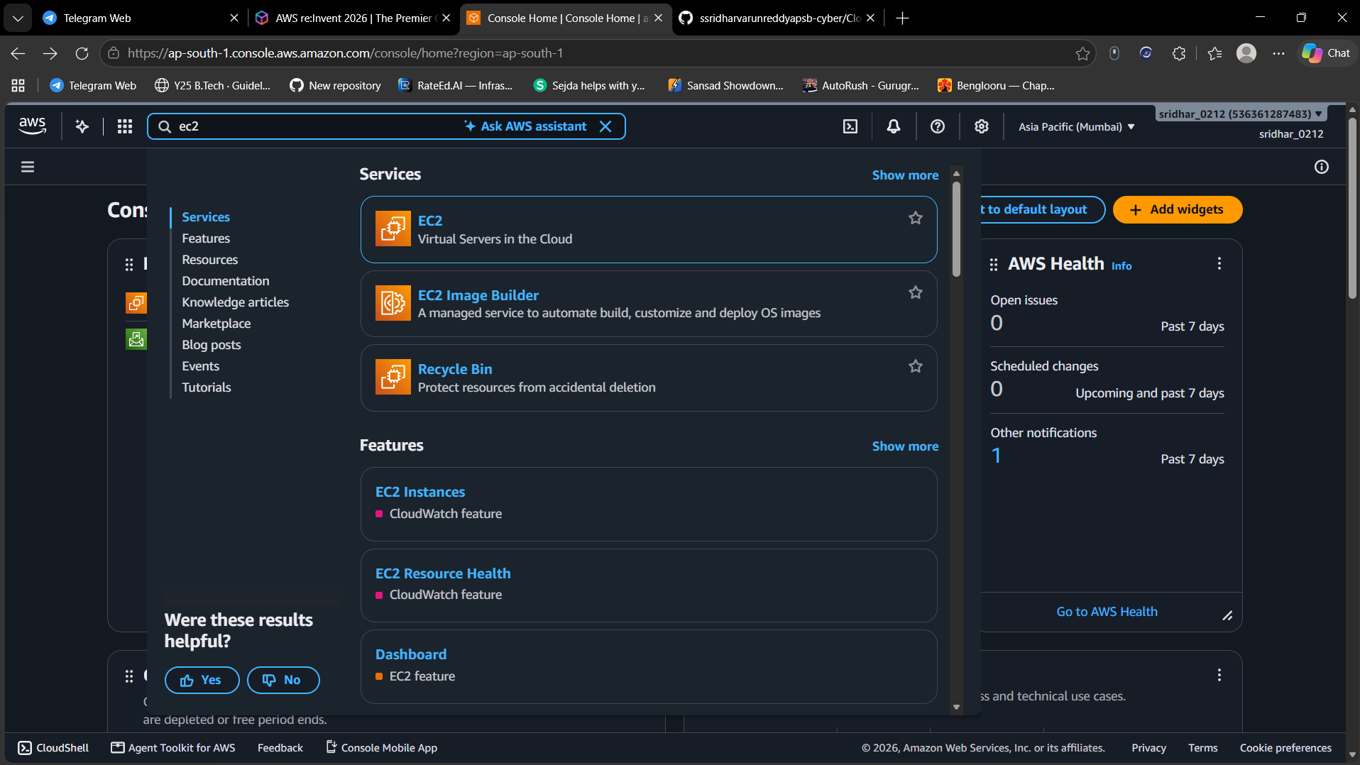
Figure 1
On the AWS Management Console home page (Asia Pacific, Mumbai region), "ec2" is typed in the search bar. The results list Services, Features, Documentation and more. The first result, "EC2 - Virtual Servers in the Cloud", is clicked to open the EC2 service.
Step 2: Amazon EC2 landing page
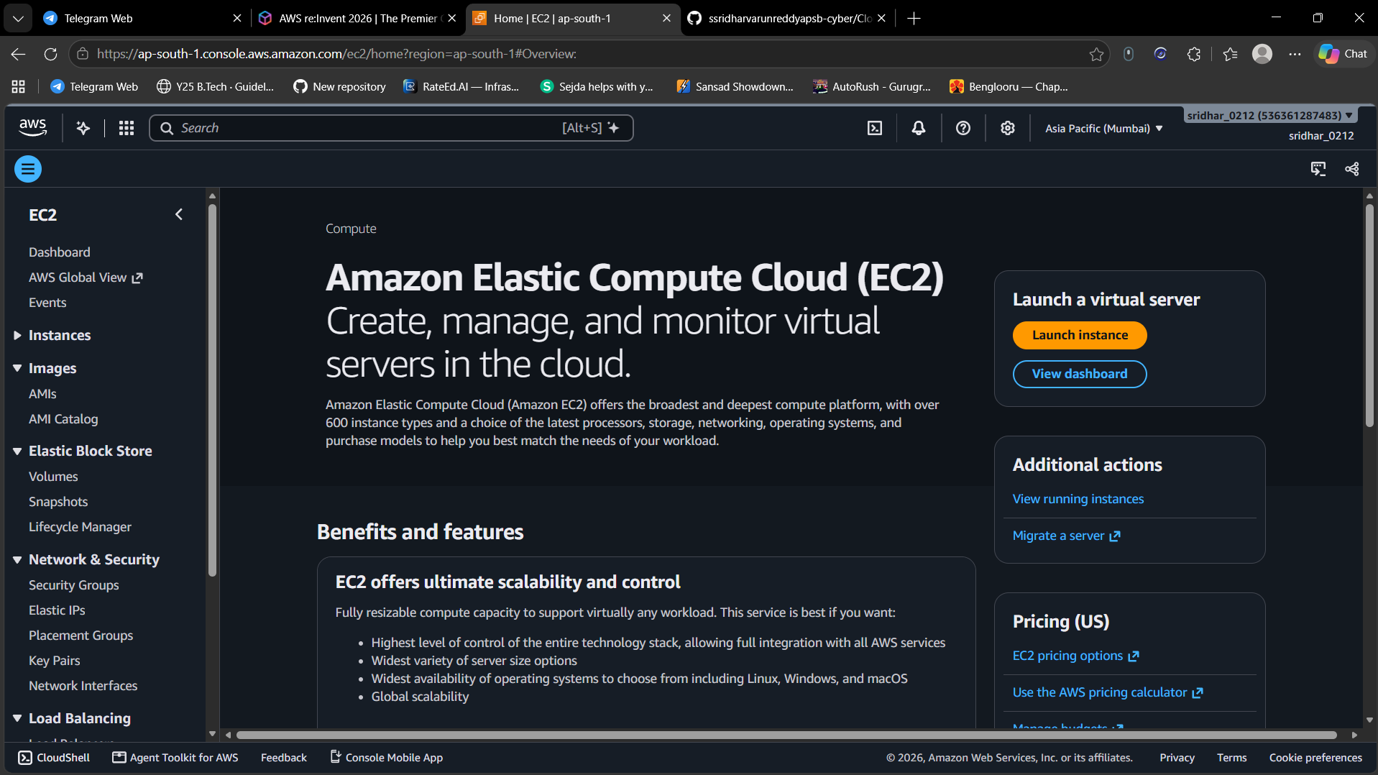
Figure 2
The EC2 service home page opens. It describes EC2 as a service to create, manage and monitor virtual servers in the cloud. The "Launch instance" button is on the right and the left navigation menu lists Instances, Images, Elastic Block Store, Network & Security and Load Balancing.
Step 3: EC2 Getting started page
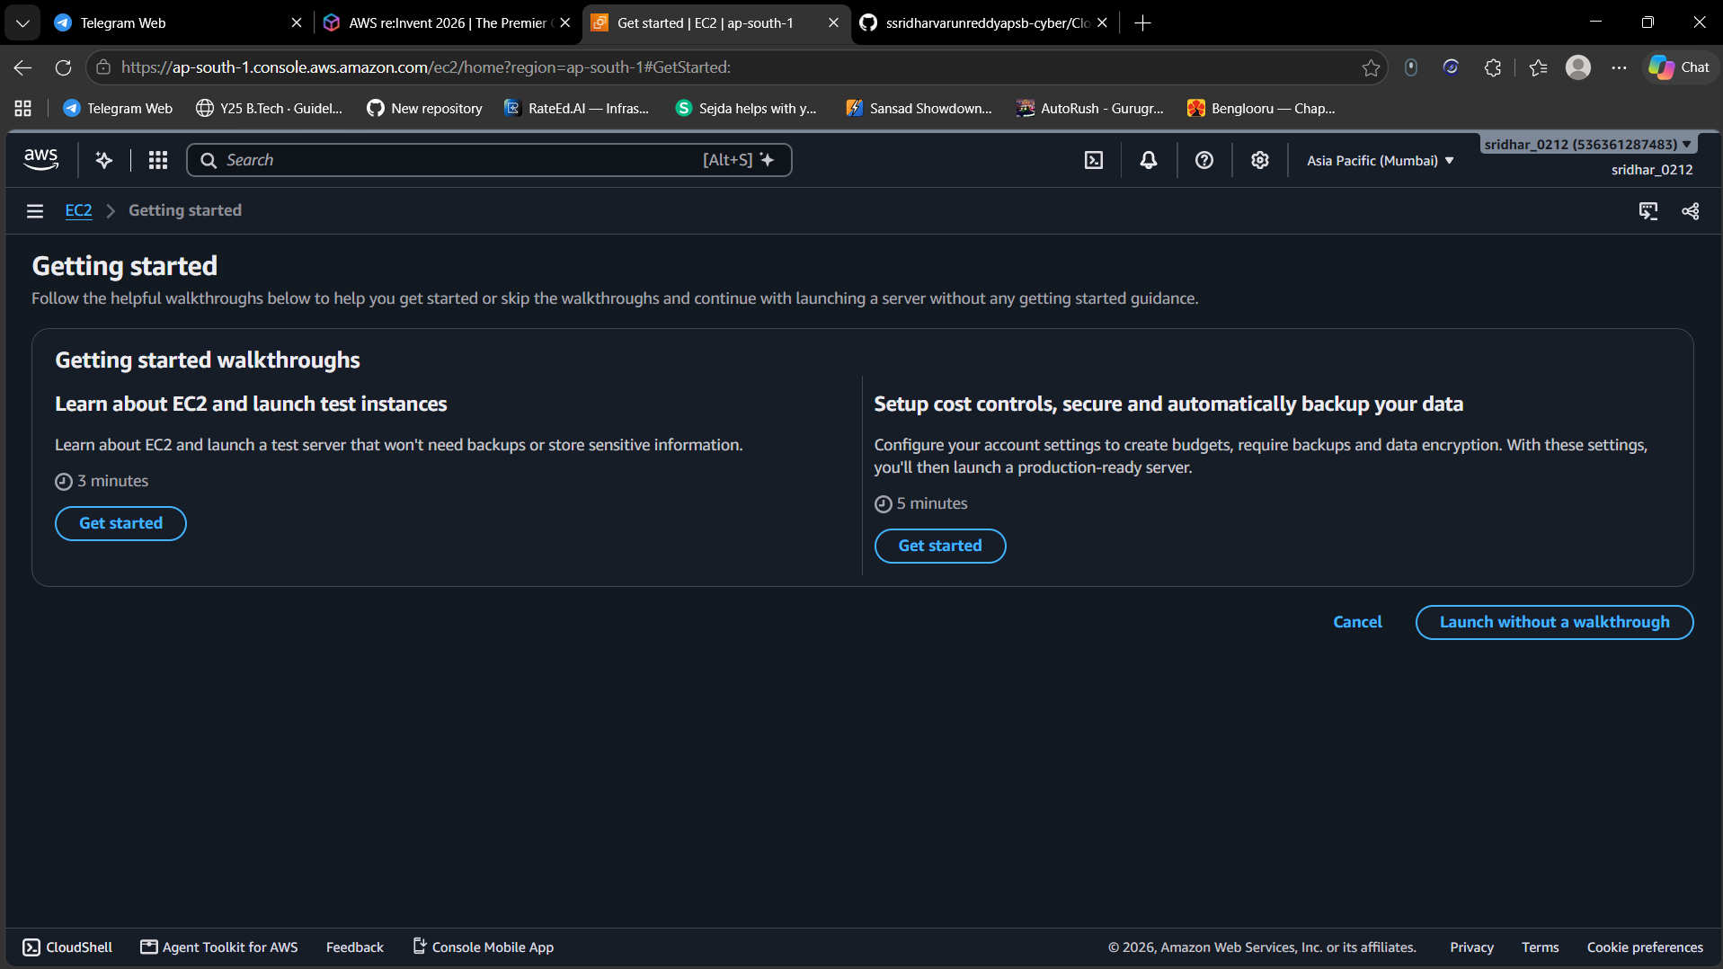
Figure 3
AWS offers optional "Getting started" walkthroughs: one for learning EC2 and launching test instances, and another for cost controls, security and backups. The walkthroughs are skipped by choosing "Launch without a walkthrough".
Step 4: Instances page (no instances yet)
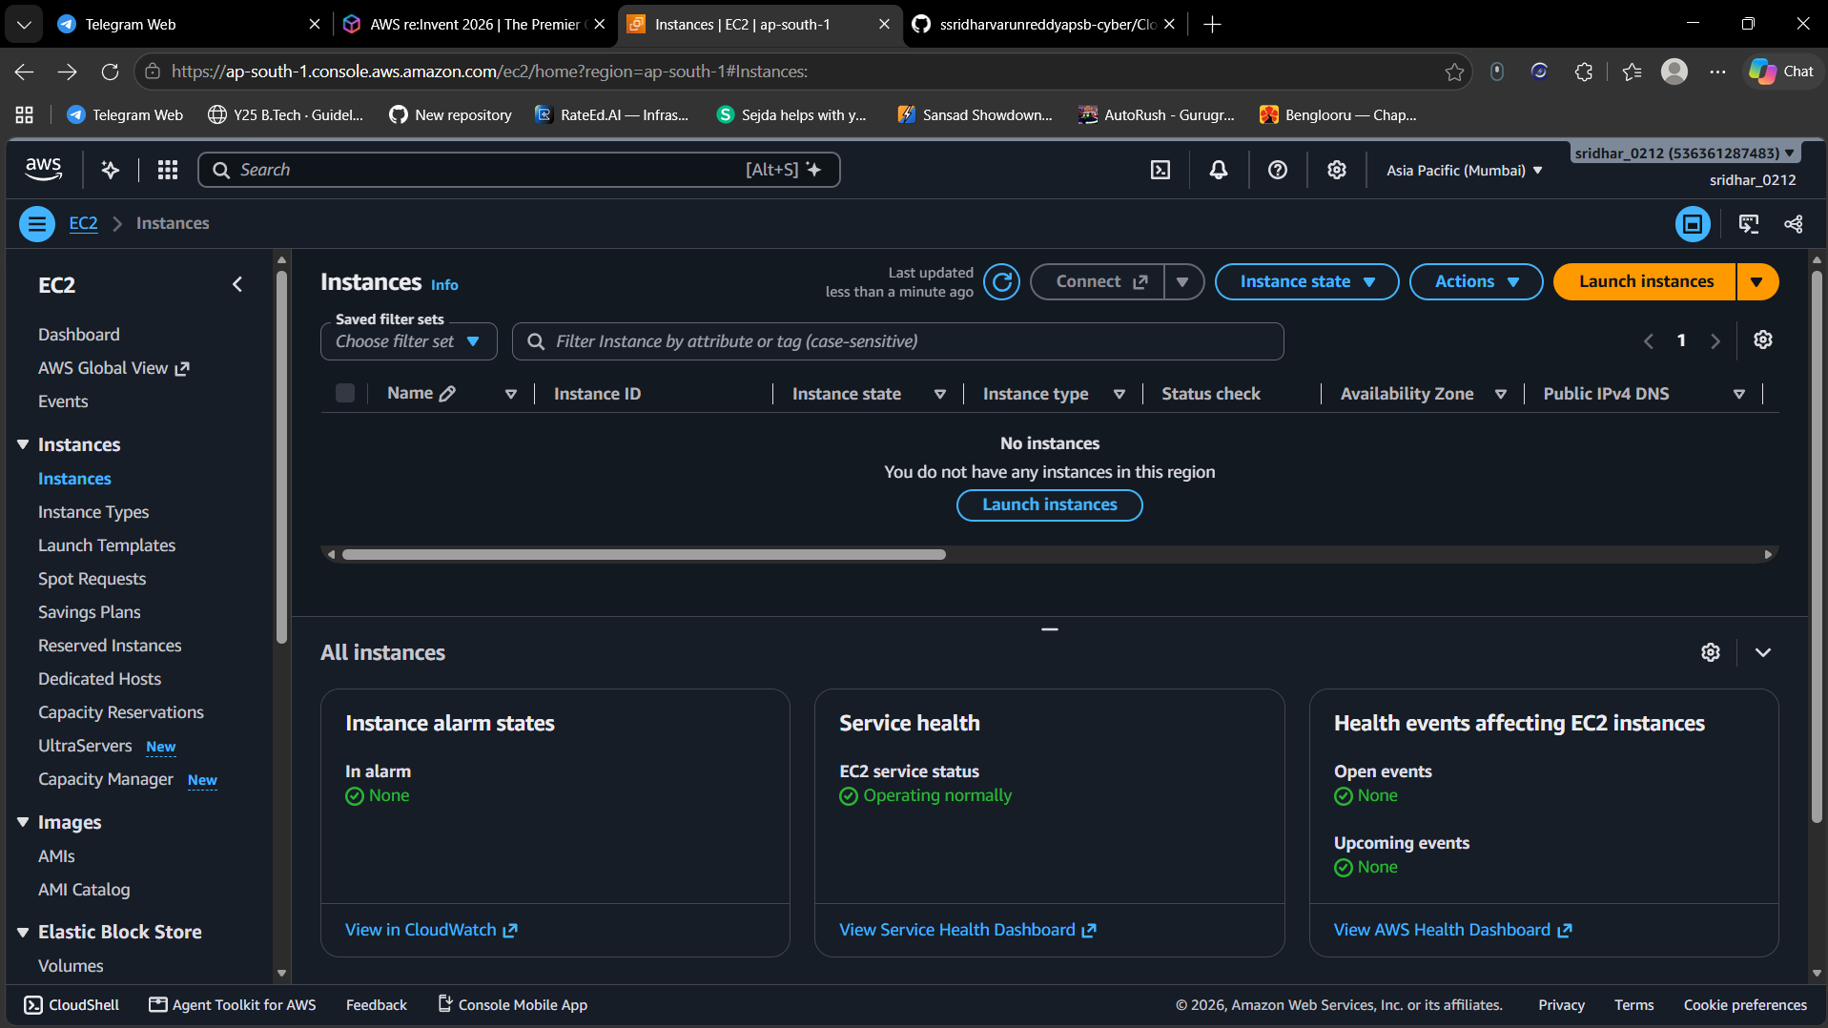
Figure 4
The Instances page shows "No instances. You do not have any instances in this region". The dashboard at the bottom shows no alarms and that the EC2 service is operating normally. The "Launch instances" button is clicked to start creating a server.
Step 5: Launch an instance: name and AMI
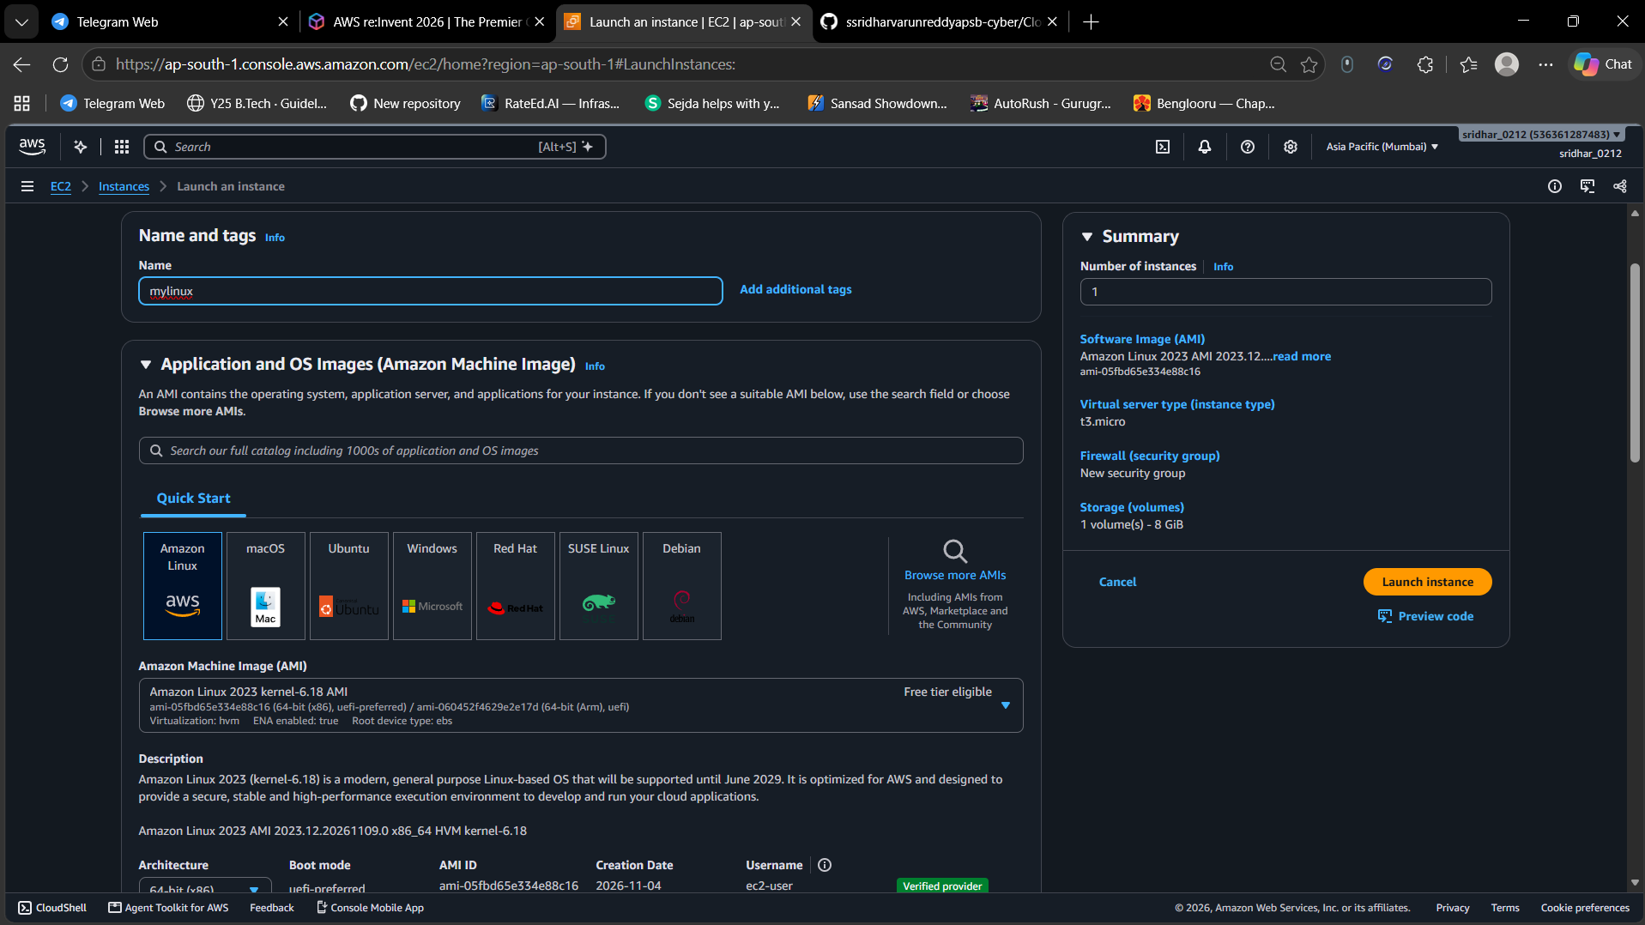
Figure 5
On the Launch an instance page the instance is given the name "mylinux". Under Application and OS Images (Quick Start), Amazon Linux is selected and the AMI is Amazon Linux 2023, marked "Free tier eligible". The Summary panel on the right shows 1 instance, instance type t3.micro, a new security group and 8 GiB of storage.
Step 6: Network rules and storage
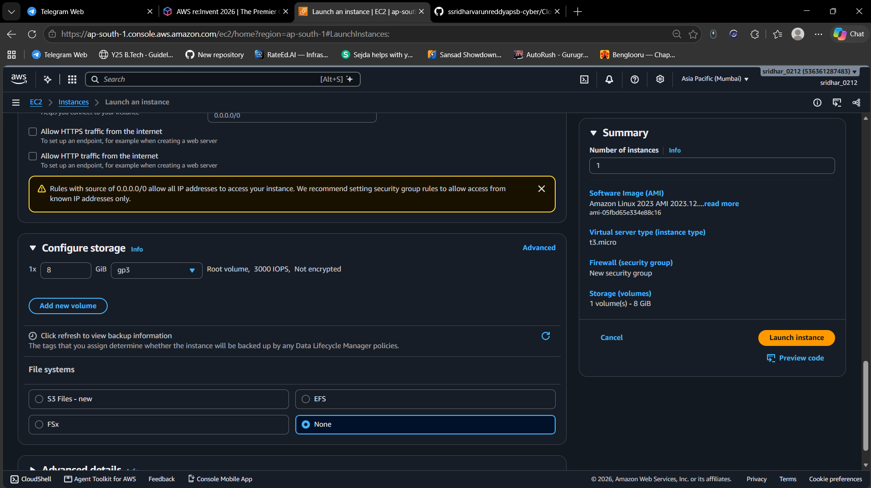
Figure 6
Scrolling down shows the security group options. "Allow HTTPS traffic from the internet" and "Allow HTTP traffic from the internet" are both unticked, and a warning says rules with source 0.0.0.0/0 allow all IP addresses. Under Configure storage, one 8 GiB gp3 root volume (3000 IOPS, not encrypted) is used and the file system option is None. The "Launch instance" button is clicked.
Step 7: Instance launched successfully
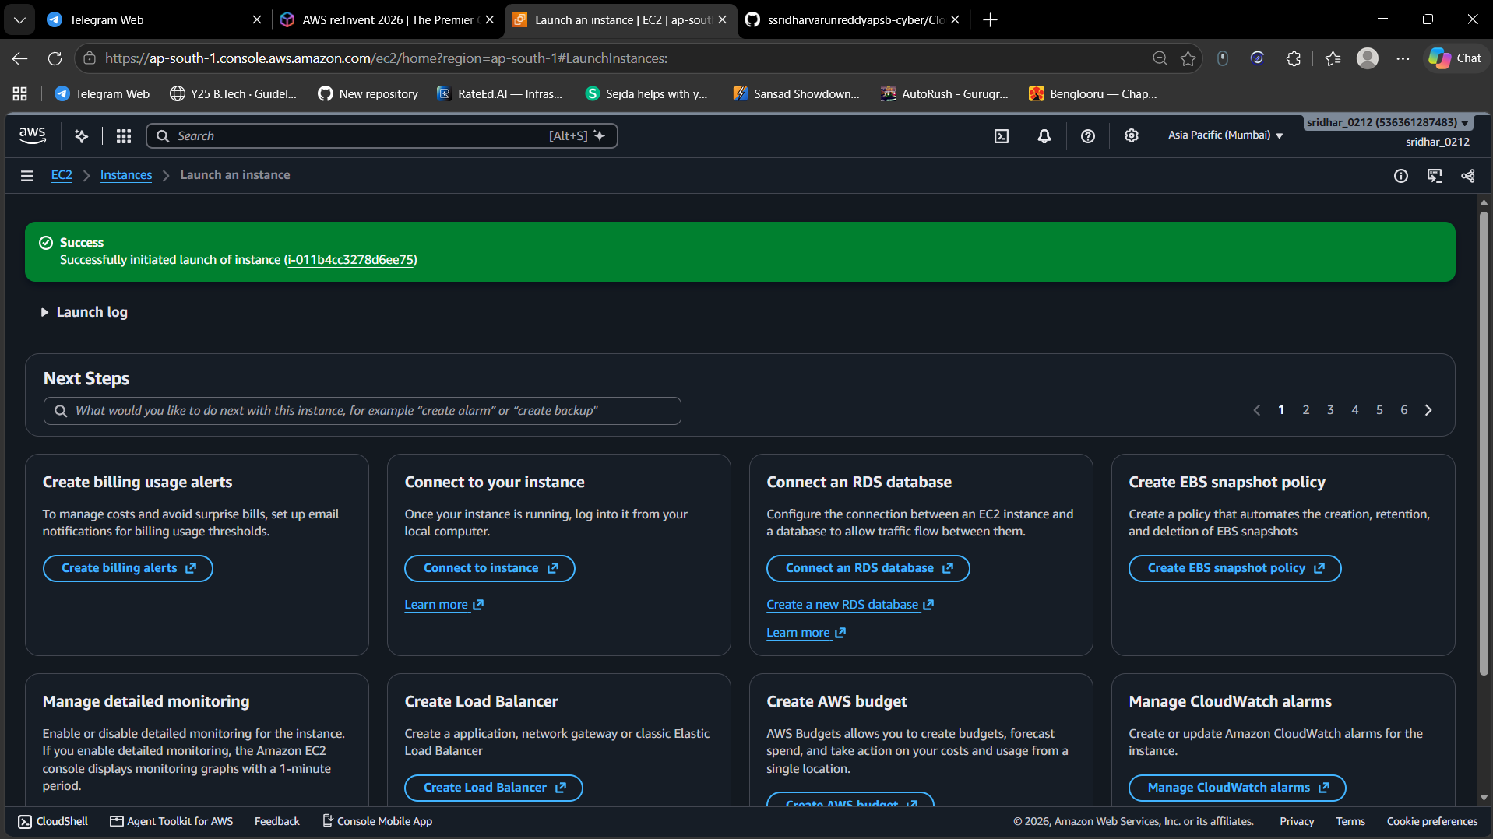
Figure 7
A green "Success" banner confirms that the launch of the instance was initiated and shows its instance ID. The "Next Steps" section offers shortcuts such as Connect to your instance, Create billing usage alerts and Create an AWS budget.
Step 8: Instance summary (running)
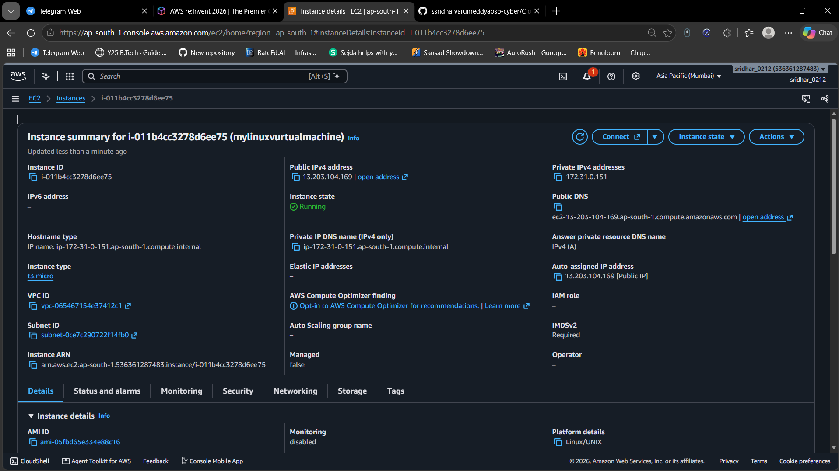
Figure 8
The instance summary page shows the instance in the "Running" state. It displays the instance ID, instance type t3.micro, public and private IPv4 addresses, public DNS name, VPC and subnet IDs, and the AMI ID. The Connect button at the top is used to log in to the server.
Step 9: Connect to instance
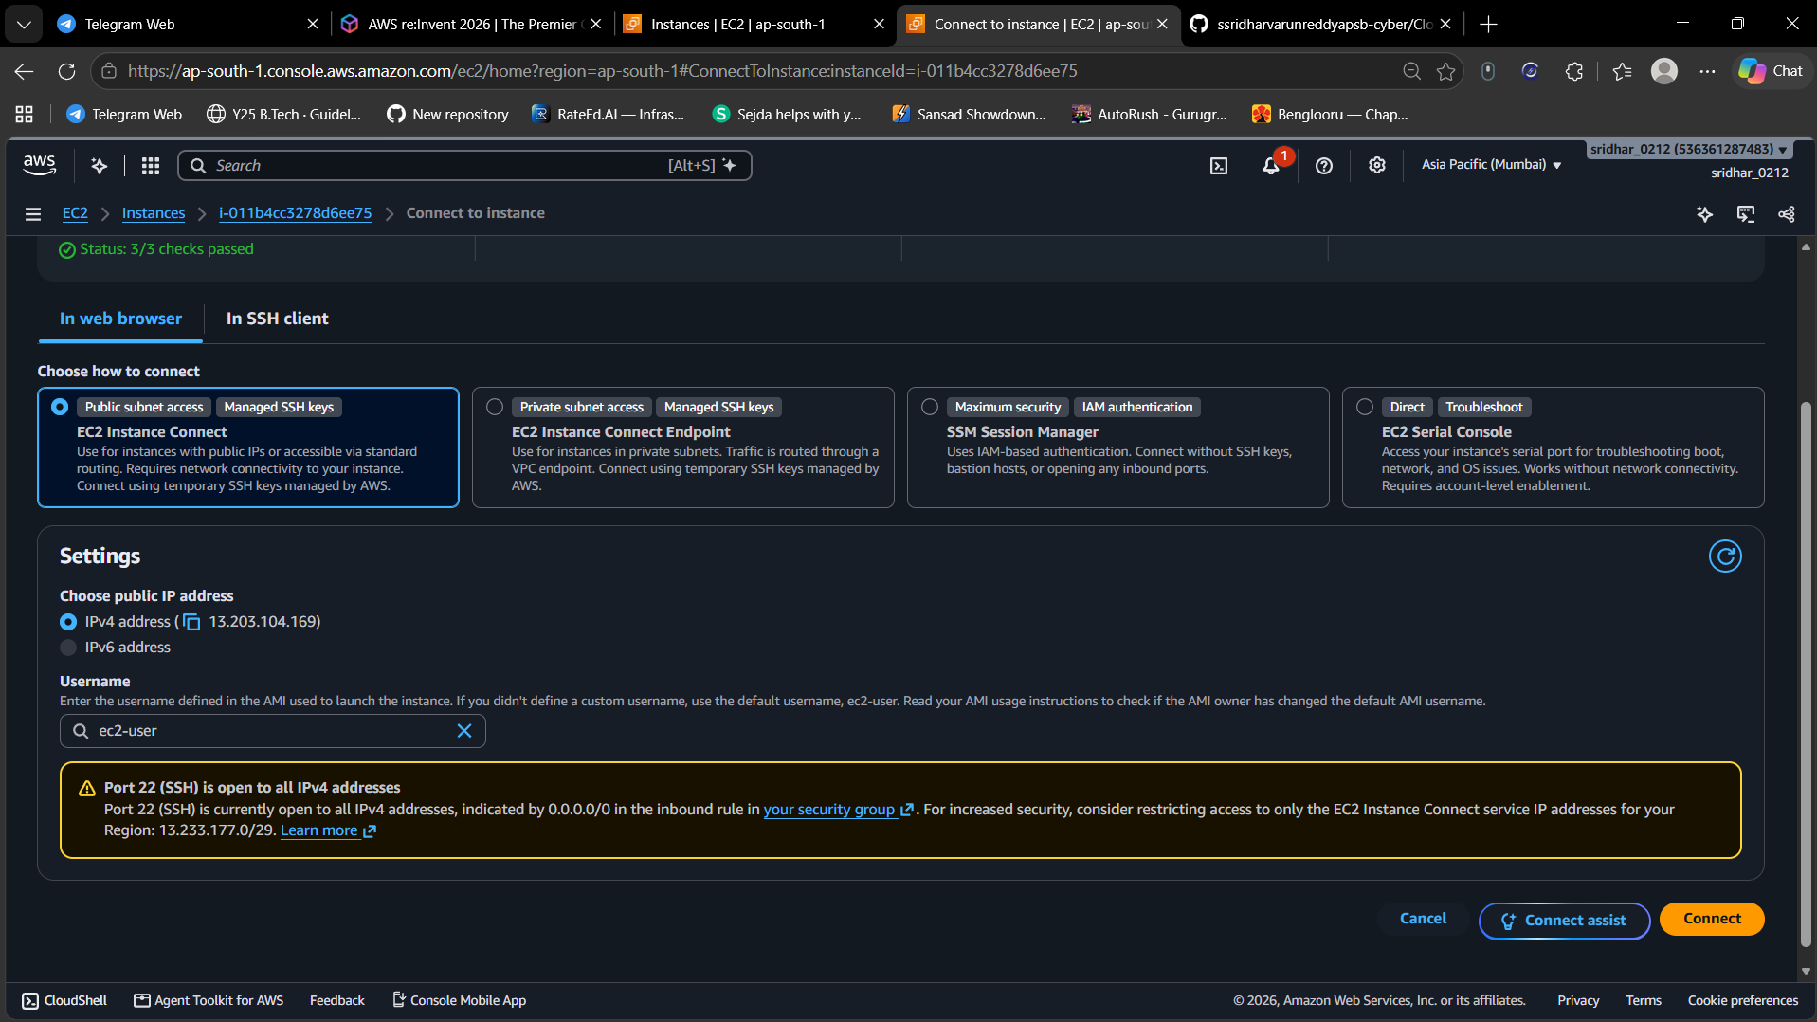
Figure 9
The Connect page shows that the status checks are 3/3 passed. The "In web browser" tab with "EC2 Instance Connect" is selected, the public IPv4 address is chosen and the default username for this AMI, "ec2-user", is filled in. A warning says port 22 (SSH) is open to all IPv4 addresses and suggests restricting it. Clicking "Connect" opens a terminal.
Step 10: Browser terminal on Amazon Linux 2023
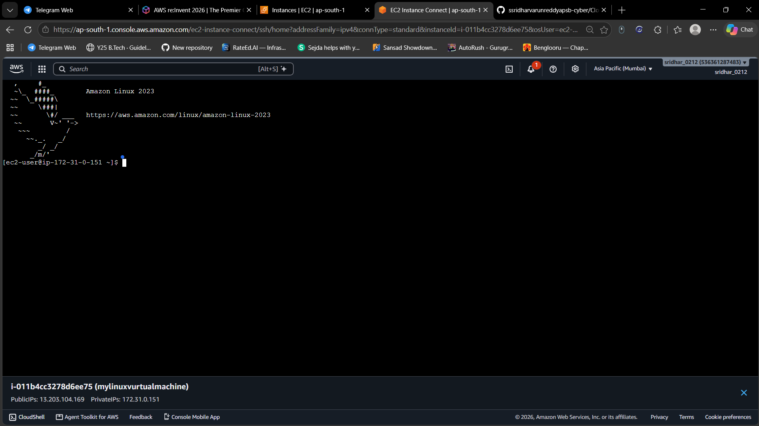
Figure 10
The EC2 Instance Connect terminal opens in a new tab. The Amazon Linux 2023 banner appears and the shell prompt shows ec2-user, which confirms the login worked. The bottom bar shows the instance ID, its name and its public and private IP addresses.
Step 11: Running Linux commands on Amazon Linux
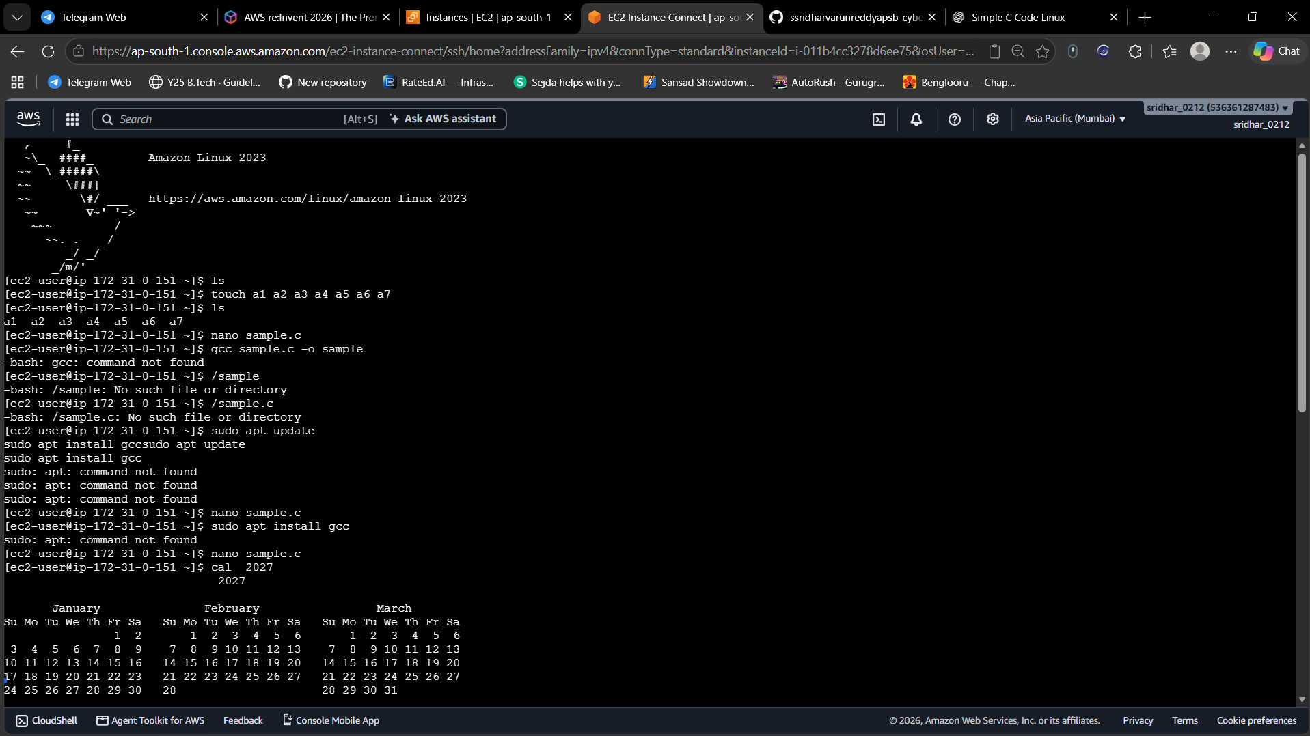
Figure 11
Basic commands are run on the server: ls lists files, touch creates seven empty files (a1 to a7) and nano opens an editor to write sample.c. Compiling with gcc fails with "gcc: command not found", so the C compiler is not installed by default. Trying "sudo apt update" and "sudo apt install gcc" fails with "sudo: apt: command not found", which shows that Amazon Linux does not use the apt package manager. The cal 2027 command prints a calendar.

